**RESUME**

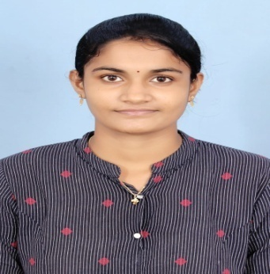

**NARINA SUJANA**

**Mobile**: +91-9381527363

**EMAIL:**sujananarina@gmail.com

**Career Objective:**

I am seeking opportunities to join a company that can help me in enhancing my skills, strengthening my knowledge and realizing my potential. I am willing to explore a wide variety of opportunities that can help me gain perspective.

**Academic Qualification:**

|  |  |  |  |  |  |
| --- | --- | --- | --- | --- | --- |
| **S.NO** | **Name of the institutions** | **Degree/ specialization** | **Board/ university** | **Year of Passing** | **Percentage/ CGPA** |
|  | Aditya degree college | B.COM | Andhra University | 2022 | 8.5 |
|  | Sri Gayatri Junior College | BiPC | Board of Intermediate A.P | 2018 | 95.4 |
|  | Aditya Public School | 10th | Board of Secondary Education | 2016 | 9.5 |

**Technical skills:**

* MS WORD
* Basic HTML

**Achievements:**

* I got certificate from career edge-knockdown the lockdown online course offered by TCS iON.
* I won **1st prize** in ACCOUNTAHOLICS conducted by **S.V.V.P** degree&P.G College.
* I won first prize in cancer day event elocution competition

**Personal skills:**

* Willingness to learn.
* Comprehensive problem solving capabilities.
* Team facilitator, hard worker.
* Fast learner.

**Personal Profile:**

Father Name : Narina Manikyala rao

Date of birth : 01-04-2000

Gender : Female

Nationality : Indian

Address : flat no - 401, Sujatha Nagar, near pendurthi, vizag,

A.P - 530051

Marital status : unmarried

Languages Known : English, Telugu.

Hobbies : Reading books, Reading newspaper, learning new

things.

**DECLARATION**

I, hereby declare that all the information furnished above are true and correct to the best of my knowledge.

DATE:

PLACE: (N.Sujana)